**Team 21 - BashGuardians - PartyGuardiOS**

**Client Name: Jacob Stansbury**

**Team member roles & responsibilities**

Spandana - S524987 - Primary Contact  
Pushpak - S525004 - Issues Management  
Vinod - S525117 - Communications and Documentation Management  
Yashwanth - S525056 - Quality and Testing Management  
Nandeesh - S525120 - Requirements Management  
Naveen - S525051 - Data Management  
Sanjeev - S525034 - Client Management

**Status Report**

Requirements discovery:

* Acquired all the requirements necessary for working on Guard user screens
* Need to receive Application logo.
* Append the application logo to every developed screen once received

Design Creation/Modification:

* Modified the User Interface for some screens as suggested by our client Jacob
* Designed separate screens for guard user

Development of Application and test Software:

* So far we have designed 5 screens and we should work on user manual screen. We have tested only a few screens.
* Used iPad for testing the modified Guard user and Host user screens.
* Tested the Forgot Password Button whether a message is sent to email for resetting it or not.

|  |  |  |  |
| --- | --- | --- | --- |
| **Team member name** | **Task Assigned** | **Link to code Snippet/Documents** | **Hours Worked** |
| Spandana | Primary contact and worked on alerts tab screen | **Link to repository:**[https://bitbucket.org/bashguardians/bashguardians (Links to an external site.)](https://bitbucket.org/bashguardians/bashguardians) | 10 |
| Pushpak | Worked on Jira issue tracking tool | Tutorial: https://confluence.atlassian.com/agile/jira-agile-user-s-guide/jira-agile-tutorials | 11 |
| Vinod | Worked on coding for basic user screen | Link to code:  <https://VinodSomu94@bitbucket.org/bashguardians/bashguardians.git> | 12 |
| Yashwanth | Worked on Test Plan and tested the forgot password button | Link to test plan: <https://bitbucket.org/bashguardians/bashguardians/src/87b611be0d666862246290e43ed8816a07a5c52f/Test%20Plan.docx?at=Home&fileviewer=file-view-default> | 10 |
| Nandeesh | Worked on More functionality for the Guard user and working on reporting an issue and alert screen | Link to repo:  [https://bitbucket.org/bashguardians/bashguardians (Links to an external site.)](https://bitbucket.org/bashguardians/bashguardians) | 10 hrs |
| Naveen | Worked on Integrated Login Web Service | Link to code:  <https://bitbucket.org/bashguardians/bashguardians/commits/9c79efef00a6c4c8c5077f1978603897e65bf754> | 11 hrs |
| Sanjeev | Worked on uploading image option to register page | Link to code:  <https://bitbucket.org/bashguardians/bashguardians/commits/91a4ef47c077069acc9f796987c890b0606c5cb0> | 11 hrs |

**Client Interaction and Documentation of calls, meetings:**

* We are updating the Client Meeting report whenever client meet happens.
* <https://drive.google.com/open?id=1FR9ZvcioBdR7Hpk3j31XQcxXHuUk8ep2aDZeKU9cOBs>
* Noting the changes specified by the client in Minutes of Meeting report.
* <https://drive.google.com/open?id=13KnLNfHwIOEgDZwxFbHwU7ldcGpwbSVuNOHQwdSfxho>

**Documentation:**

* We are updating Client Meeting Report on a weekly basis.
* Link: <https://drive.google.com/open?id=1FR9ZvcioBdR7Hpk3j31XQcxXHuUk8ep2aDZeKU9cOBs>
* Minutes of meeting document is updated after each client meet.
* Link: <https://drive.google.com/open?id=13KnLNfHwIOEgDZwxFbHwU7ldcGpwbSVuNOHQwdSfxho>

**Link to repository**

<https://bitbucket.org/bashguardians/bashguardians>

**Work in Progress:**

By the end of this week we will be able to complete the following tasks:

**Time remaining for each person:**

|  |  |  |
| --- | --- | --- |
| **Team Member** | **Tasks In Progress** | **No of hrs. remain** |
| Spandana | Will complete the coding on alert screens | 5 |
| Pushpak | Will track the issues on host and guard user screens using jira | 4 |
| Vinod | Complete coding on basic user screen | 3 |
| Yashwanth | Write test specification for unit testing and update the test plan | 5 |
| Nandeesh | Work on reporting issue screen and emergency button | 5 |
| Naveen | Complete integration of login web services | 4 |
| Sanjeev | Complete register page of the host and guest user | 4 |

**Screenshots of major artifacts for accomplishments:**

1. **Guard User Login screen**

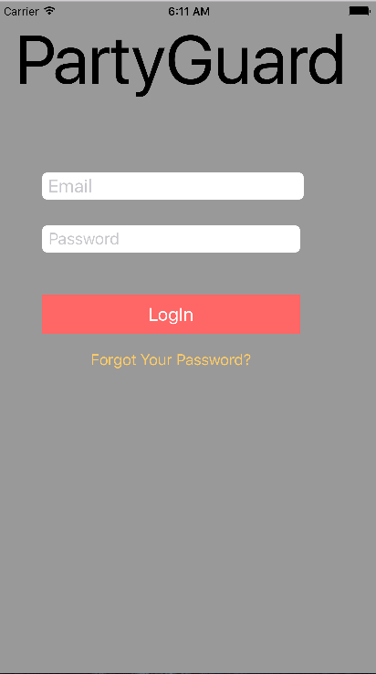

1. **PG Team tab**

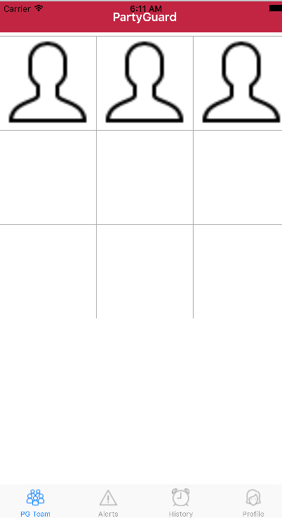

1. **Alerts tab**

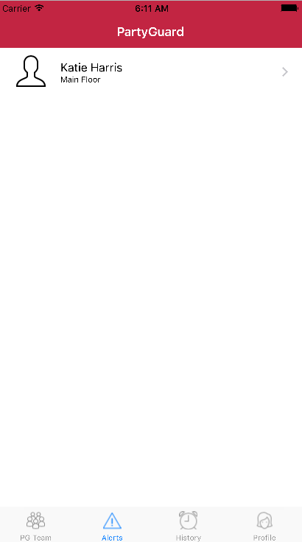

1. **History tab**

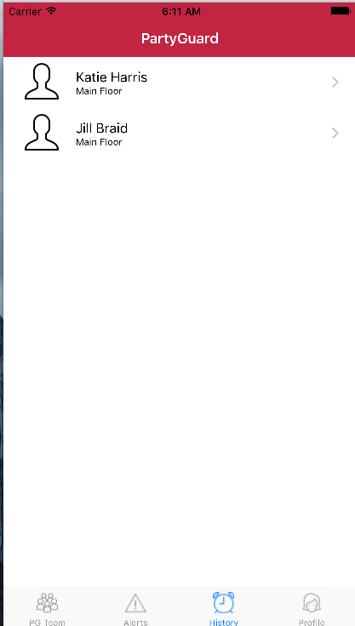

1. **Profile tab**

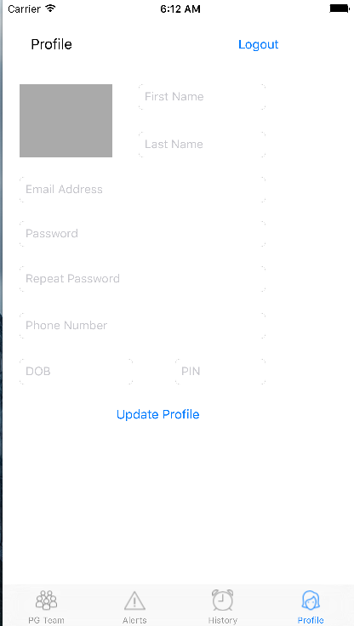

1. **Forgot Password**

